When cloning Marcin’s AspergillosisEPR solution from GitHub, Solution will not compile.

Need to delete some of the classes in AspergillosisEPR\Lib\Importers\Implementations

MortalityAuditDatesSGRQImporter.cs

I removed all the MortalityAudit importers in my version.

Tried to get another copy of Marcin’s AspergillosisEPR into my own repository following below, but failed

[Mirroring a repository that contains Git Large File Storage objects](https://docs.github.com/en/github/creating-cloning-and-archiving-repositories/duplicating-a-repository#mirroring-a-repository-that-contains-git-large-file-storage-objects)

1. Open Git Bash.
2. Create a bare clone of the repository. Replace the example username with the name of the person or organization who owns the repository, and replace the example repository name with the name of the repository you'd like to duplicate.

$ git clone --bare https://github.com/*exampleuser*/*old-repository*.git

1. Navigate to the repository you just cloned.

$ cd *old-repository*.git

1. Pull in the repository's Git Large File Storage objects.

$ git lfs fetch --all

1. Mirror-push to the new repository.

$ git push --mirror https://github.com/*exampleuser*/*new-repository*.git

1. Push the repository's Git Large File Storage objects to your mirror.

$ git lfs push --all https://github.com/*exampleuser/new-repository.git*

1. Remove the temporary local repository you created earlier.
2. $ cd ..

$ rm -rf *old-repository*.git

Ended up with:

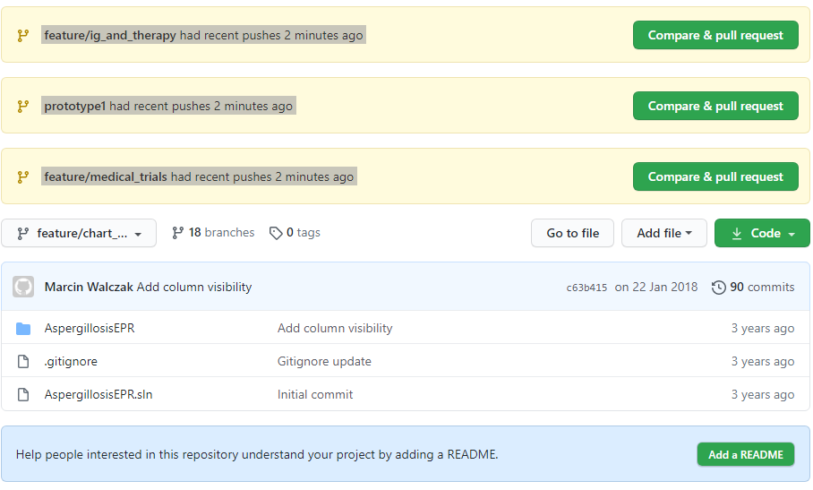

Something to do with:

! [remote rejected] refs/pull/1/head -> refs/pull/1/head (deny updating a hidden ref) errors but don’t understand why!